Ohm’s Law
Equipment Needed

Dell Laptop Computer
AC/DC Power Supply, Dell Laptop Computer
AC/DC Electronics Laboratory, Pasco EM-8656
Ammeter, Analog EMD S52222B
Battery, D Cell in Laboratory 2x
Lead, alligator/alligator 2x
Multimeter, Digital (DMM) 2x
Power Supply, Fisher-EMD Battery Eliminator
Resistor, 100Ω

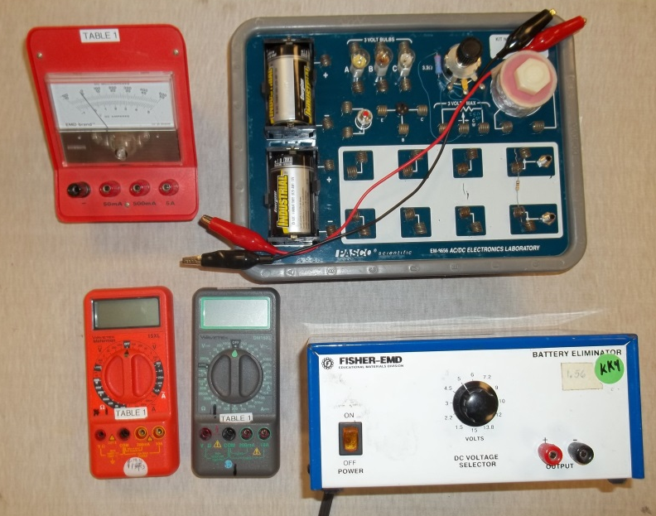
Introduction
In this activity we will examine the factors that determine the amount of current that flows in a resistive circuit. Part I will examine the correct use of meters. Part II will look at the relationship between potential difference and current for circuits called Ohm’s Law.
Part I—Use of Voltmeters and Ammeters
In the following procedure, disconnect your circuits when not making observations to preserve battery life.
Use AC/DC Electronics Laboratory circuit board and connect the two D cells in series and connect the batteries across two light bulbs in series. Your circuit should appear something like the following schematic.
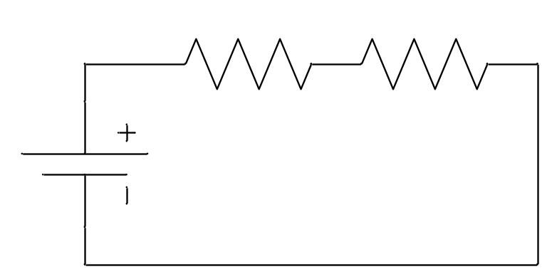
Observe the brightness of the light bulbs, and open the circuit.
When we depict a meter on a schematic we show it by a circle with letter inside designating the type of meter. Thus a voltmeter will be a circle with V inside and and ammeter will be a circle with an A inside. Potential differences are measured across objects so when using a voltmeter—or a DMM in voltmeter setting—we place the probes on either side of the object.
- Close the circuit and use the DMM to measure the potential difference across each resistor and record the values. Both values should be positive so reverse the orientation of the leads if you measure a negative value.
__________
__________
- Find the sum of the potential differences.
__________
- Measure the potential difference across both resistors and record.
__________
- How does your answer to #3 compare to #2? Explain why this should be the case.
- Measure the potential difference across the battery and record.
__________
Open the circuit again.
- How does your answer to #5 compare to #2? Explain why this should be the case.
Now we will find out what happens when we connect a voltmeter incorrectly. Instead of using the voltmeter across a resistor, let us connect it in series with the circuit. Connect the following circuit. Note: to put a new element in series, you must make a break in the current circuit.
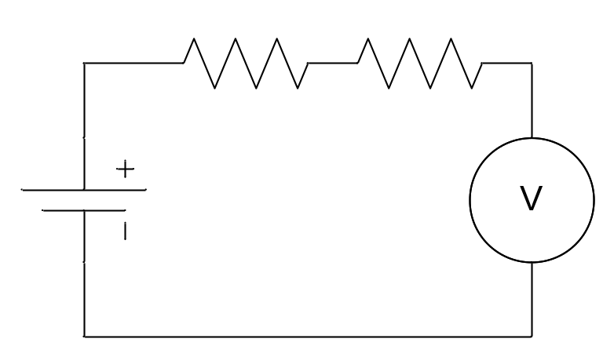
- What happens to the light bulbs when you place the voltmeter in series with the circuit?
- Does this suggest that a voltmeter has a high resistance or a low resistance? Explain.
Now we will examine using an ammeter. Current flows through a circuit. To measure it, the current must flow through the ammeter. Thus when we use an ammeter correctly it must be placed in series in the circuit.
Remove the voltmeter from the circuit and reconnect the battery across the two light bulbs in series. Take a piece of alligator clip wire and short out one of the light bulbs by connecting the wire from one side of the socket to the other.
- What happens to the other light bulb?
- Did the current increase or decrease when the first light bulb was shorted out?
Disconnect the short circuit.
Now we will use an ammeter incorrectly and see what happens. It is very common for people to connect an ammeter like it was a voltmeter, Namely to connect it across a circuit element instead of putting it in series with the circuit. Clip one alligator clip lead onto the black common terminal on the ammeter and the other onto the 5A terminal. This means that the ammeter will read 0—5 A. If the lead was connected to the 500 mA terminal it would read 0—500 mA and so on. Connect the ammeter across one of the light bulbs and observe what happens. Disconnect once you have made your observation.
- Describe what happens. Did you short out the light bulb?
When you connect an ammeter across a circuit element, you create a short circuit and increase the current in the circuit. This can be dangerous and at the very least can damage the ammeter. Ammeters must always be connected in series with circuit.
Connect the ammeter in series with the light bulbs between the positive terminal of the battery and the first light bulb.
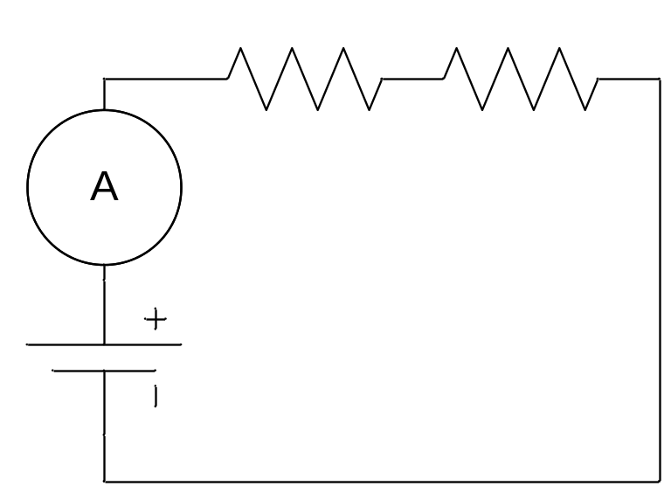
- Are both bulbs now lit?
- Record the current. Note if the needle seems to be deflecting to the left, reverse the leads.
- Does it matter where in the circuit you place the ammeter? Explain.
Connect the ammeter so that it is in series between the two light bulbs.
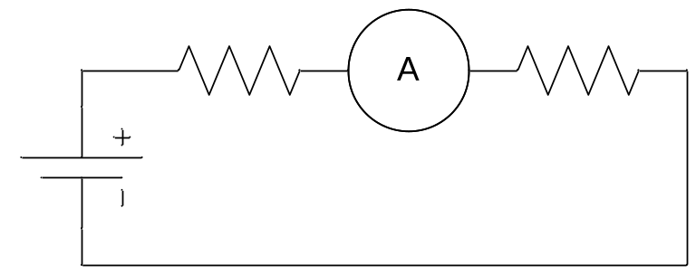
- Record the current.
- How does the current recorded in #15 compare to the current recorded in #13
Connect the ammeter in series so that it is between the light bulb and the (–) terminal of the battery.
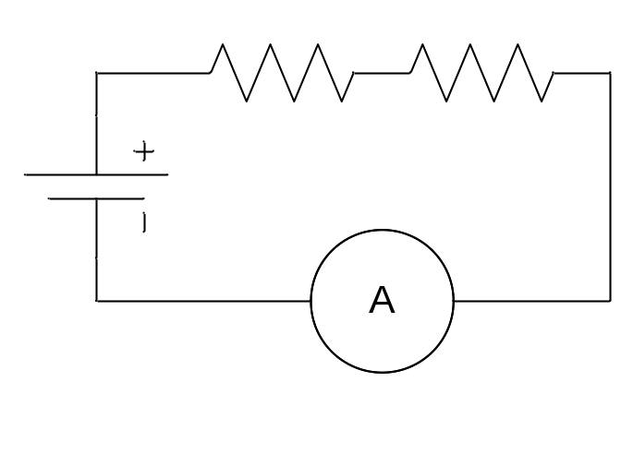
- Record the current.
- How does the current recorded in #17 compare to the currents recorded in #15 and #13.
- What does your answer to #18 suggest about the behavior of current in a series circuit?
Part II—Ohm’s Law
Procedure
Set-Up
Place the 100Ω resistor between empty coils on the Laboratory circuit board as shown. Construct the circuit shown below using the 100Ω resistor. In the circuit diagram the symbol for the potential difference with an arrow drawn through it indicates a variable potential difference.

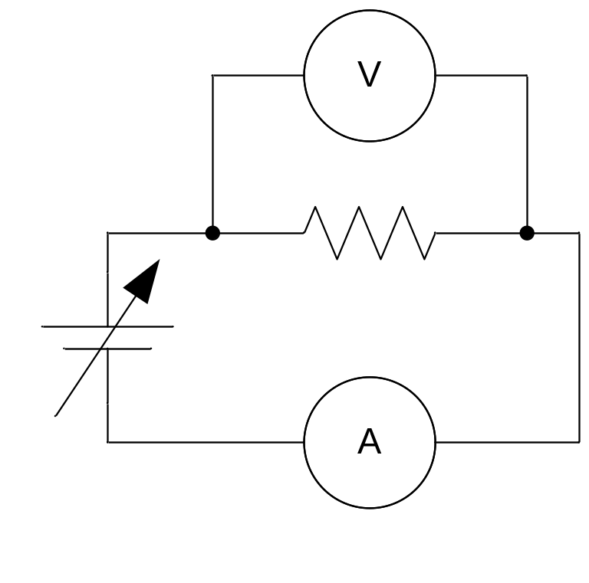

Make sure that the power supply is turned off. Configure one DMM to be a voltmeter in the 20VDC range and connect it as shown across the resistor as shown. Configure a second DMM to be used as an ammeter by plugging one lead into COM and the other into the socket marked 2A. Connect the ammeter in series with the resistor and the other DMM configured as a voltmeter across the resistor. This way we will measure the potential across the resistor and the current through it. Note: Before turning on the power supply, check your circuit with the instructor. Incorrect circuits will result in blown fuses and possible damage to the DMM.
Using the lowest 5 settings on the power supply, collect and record Potential Difference versus current data for the 100Ω resistor.
Record your data in the table below.
Reverse the leads to the power supply only, so that you apply a negative potential difference across the circuit. Measure and record Potential Difference (V) versus Current (A) in your data table for the lowest 5 settings on the power supply.
Current (A) | Potential Difference (V)
0A | 0V

Data Analysis
Using your data for both positive and negative values, construct a graph of Voltage versus Current with LoggerPro. (Remember it is y vs. x)
- Does your data seem to lie along a line?
- Does the line seem to go through the origin? (Or at least very close?)
- What type of relationship is represented by a line that goes through the origin?
Click on the linear regression button 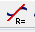. LoggerPro will use a statistical procedure and find the line which most closely matches the data—referred to as a best fit line.
Print and attach your graph.
- How does the slope of the line compare to the resistance of the resistor?
- Fill in the blank with the appropriate type of mathematical relationship. For a resistor, the potential difference is __________ to the current.
This idea is Ohm’s Law.

